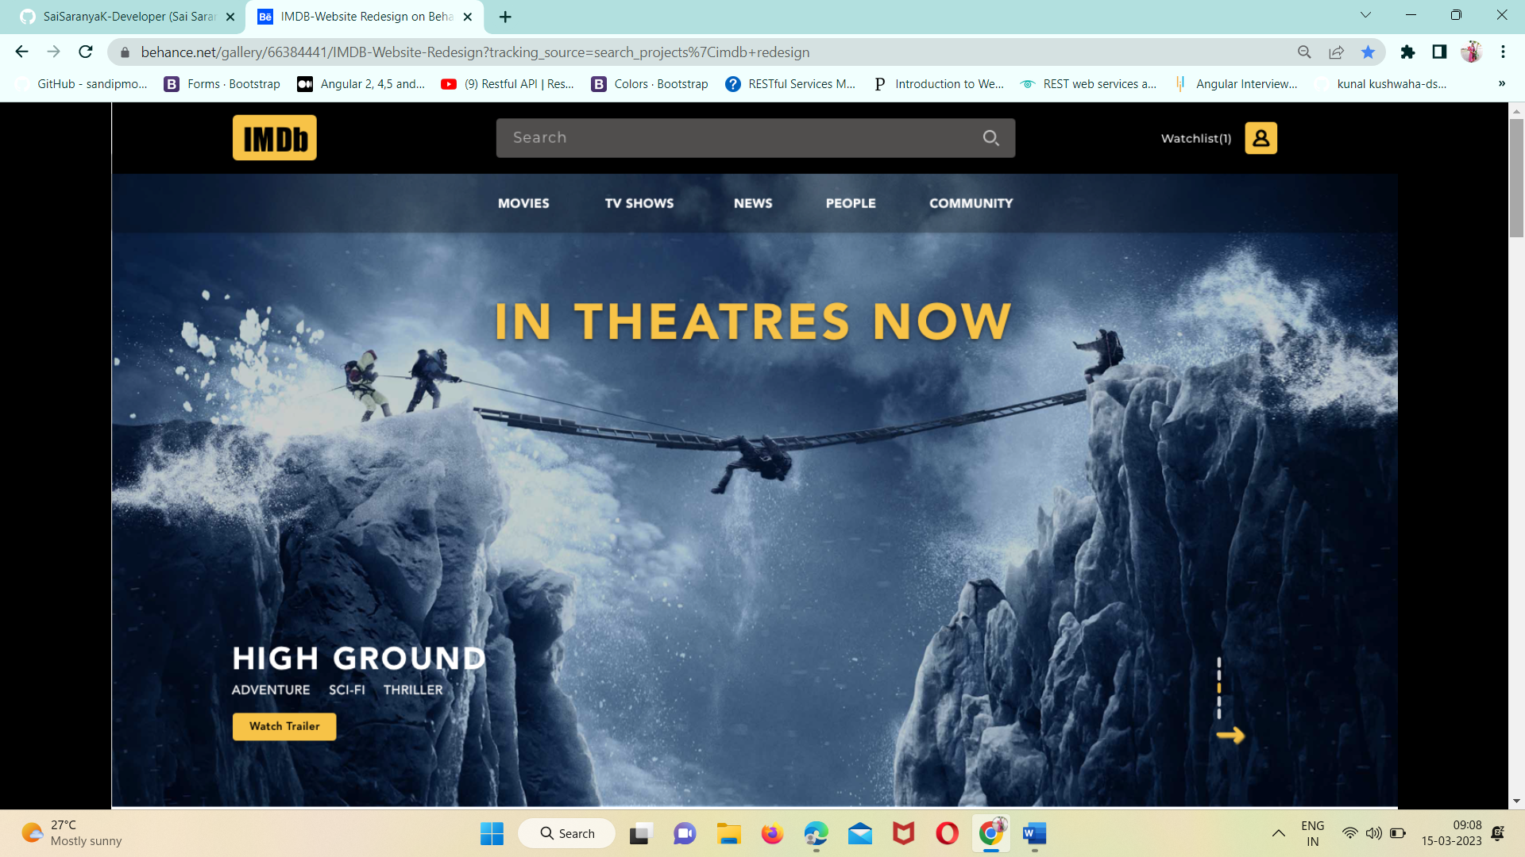

**PROJECT NAME: IMDB WEBSITE**

**IMDb website** is the world's most popular and authoritative source for movie, TV and celebrity content. On this website, we can rate our favourite movies & shows and see the reviews for the newest movies and TV shows.

***WEBSITE STRUCTURE***:

1. Navbar section
2. Movie posters section
3. Theatre arrival section
4. Fan favourites section
5. Exclusive videos section
6. Ott Streaming section
7. Top news in the entertainment field section
8. Recently viewed section
9. Footer section with social links

**Technologies used:**

* Front-end :

HTML, CSS, JavaScript, ReactJS

* Database:

Mongo dB, JSON data

* Code compilers:

Visual studio code, Git bash, Git hub, Node js.

1. Navbar

Navbar contains:

* IMDB icon
* Search bar
* Watchlist icon
* Sign up & Sign in buttons- During sign up it will take the users email, name, phone number, & password and store them in the database

2. Movie Posters

This section displays the animation of newly arrived movie posters with the movie name, movie genre, movie duration, and a link to the trailer of the movie.

3. Theatre arrival

This section contains a row of movies (along with a slider) that are newly released in theatres with movie duration and trailer links of their respective movies.

4. Fan Favourites

This section contains a row of top-rated movies and shows of the week/month. On clicking a particular movie or show, it will redirect to the page which contains the movie trailer, ratings (we can rate the movie as well), reviews, the Storyline of the movie and the cast & crew of the movie.

5. Exclusive videos

This section of the website contains videos of Celebrity interviews, trending entertainment stories, and expert analysis of the movies/shows.

6. OTT Streaming

This section contains two rows, one with different Ott platform names (ex: prime video, Netflix, Aha) and another row with the movie poster, trailer link, and ratings of the movies streaming in the corresponding Ott platform.

7. Top news

This section contains a row of Headings and Highlights of top news in the entertainment field with the link “read more” redirecting to the full article about that particular headline.

8. Recently viewed

This section contains the Recently viewed movies & shows lists. It also contains the clear option to delete all the history of recently watched trailers of movies and shows.

9. Footer

The footer section contains the copyright notice, link to a privacy policy, logo, contact information, social media icons, sign-in option and developer details.